Case 4: International Diversification

**Step 1.1 : Gross Domestic Product, Consumption and Equity Capitalization**

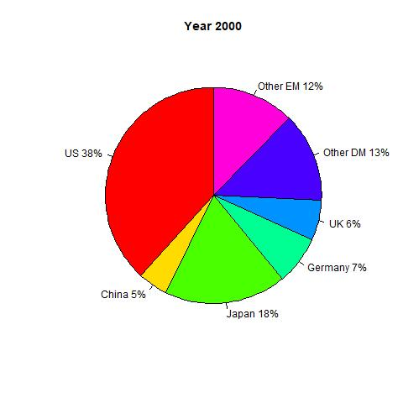

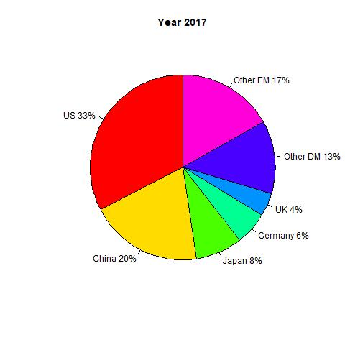

1. Gross Domestic Product in 2000 (b) Gross Domestic Product in 2017

Figure 1.1 GDP Pie Chart

The above two pie chart shows Global Domestic Product (GDP) of all countries in 2000 and 2017. The U.S. markets contributed 38% of the total GDP in 2000. However, this percentage goes slightly down to 33% in 2017 due to China’s GDP growth in this period of time. China contributed 5% of the Global Domestic Product in 2000 and surprisingly goes up to 20% in 2017 due to many business in the US moving from US to China. Since China had a low labor cost and less regulation in the country. Germany contributed 7% of the Global Domestic Product in 2000 standing at the third place behind Other Developed Market at the second place where we see around 13% of the global GDP. UK contributed 6% of the Global Domestic Product in 2000 and slightly down to 4% in 2017. The Emerging Markets contributed 12% of the Global Domestic Product in 2000 and went up to 17% in 2017. Sum up, in the two picture we could see thedeceleration in US GDP from 2000 to 2017, and the growth are giving away to China and Emerging Market.

**Step 1.2-D2D5 : FIG Create a pie chart for Equity Capitalization total (all countries)in US dollars at the end of Year 2017 and Year 2000.**

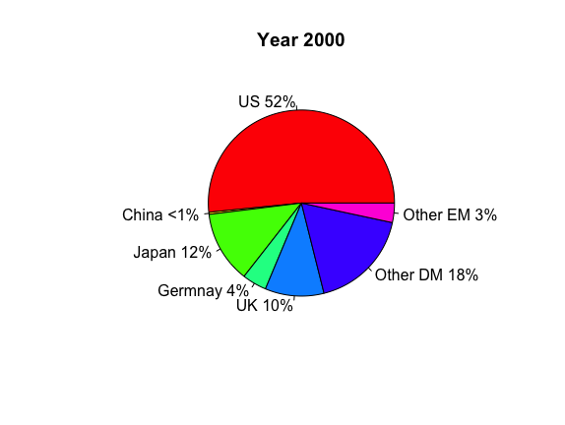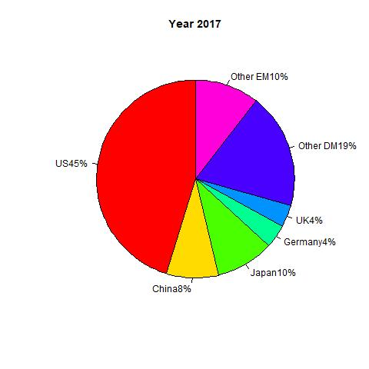

(a) Market Capitalization in 2000 (b) Market Capitalization in 2017

Figure 1.2 Market Capitalization Pie Chart

The above two pie chart shows Market Capitalization in 2000 and 2017. The U.S. markets contributed 52% of the world market capitalization in 2000 and 40% in 2017, which explains that US is the largest market capitalization in the world . China contributed less than 1% of the world market capitalization in 2000 and around 8% in 2017. This explains us, since China join free trade agreement in 2001 had impact to the China’s market capitalization. There were more Chinese companies started to list into stock market and there were more outside investor who were willing to invest more in the Chinese market due to political shift. As we see in the pie chart Japan had a large contribution at 12% of the world market capitalization in 2000 and slightly down 10% in 2017. UK contributed 10% of the world market capitalization in 2000 and this number went down to 4% in 2017. In 2000, other developed countries contributed 18% market capitalization total, and in 2017 other developed countries’ contribution went up to 19%. The other emerging markets contributed 3% of the world market capitalization in 2000 and 10% in 2017. This could tell us a story that, there are potential growth in the Emerging market due to investment less risker compare to 2000 and investors believe there are the potential growth in the market that will generated the future cash flow from the investment.

**Step 1.3-D1 : FIG Create a time-series for GDP (DM, EM, US, China) in US trillion dollars.**

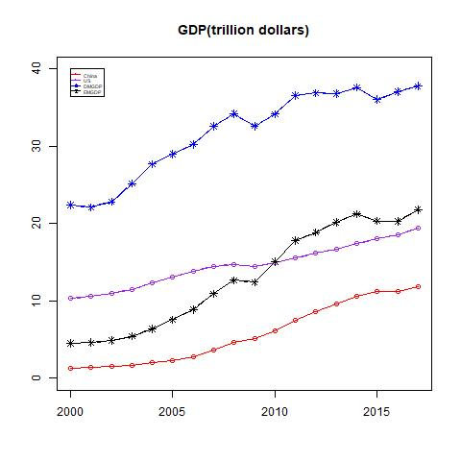

Figure 1.3 Time-series plot for GDP (DM, EM, US, China) in US trillion dollars

This graph displays the total GDP in US dollars. How the trend of the GDP as years go by. The x-axis shows the time series, which are the year from 2000 to 2017. The y-axis displays the GDP in US Dollar from 0 trillion USD to 40 trillion USD. The blue line represents the total GDP in the Develop Market. The black line represent the sum of GDP in the Emerging Market. At meanwhile, the purple line represents the total GDP in United State, and the red line represents the China GDP. As we see in the picture, Developed Market has the highest GDP started from 23 trillion dollars in 2000 to 39 trillions dollars in 2017. Surprisingly, Emerging Market in 2000 was 5 trillion dollars in the third place compared to US was at 10 trillion dollars. However, at the end of 2017, the Emerging Market stood at the second place generated about 20 trillion US dollars in GDP slightly above the US at 18 trillion dollars. The GDP of China in 2000 was 1214 billions US dollars, however, there was a huge GDP growth in China from 2000 to 2017. Total GDP in China had 11 trillion US dollars in 2017. This explains that Chinese government successfully adopted with policy that this communist country moved from close market to a free trade market in 2001.

**Step 1.4-D2D5 : FIG Create a time-series for Equity Capitalization (DM, EM, US, China) in US trillion dollars.**

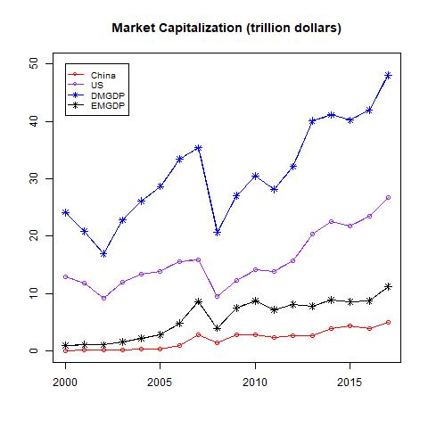

Figure 1.4 Time-series plot for Equity Capitalization (DM, EM, US, China) in US trillion dollars

This graph displays how the trend of the Equity Capitalization as years goes by in US dollars of the U.S., China, the Developed Market and the Emerging Market. The x-axis shows the time series, which are the year from 2000 to about 2017. The y-axis displays the Equity Capitalization in US dollars from 0 trillion USD to 50 trillion USD. The blue line represents the total Equity Capitalization in the Develop Market. The black line represent the sum of Equity Capitalization in the Emerging Market. At meanwhile, the purple line represents the total Equity Capitalization in the United State, and the red line represents the Chinese Equity Capitalization. As we see in the picture, the Developed Market has the highest Equity Capitalization started from around 25 trillion dollars in 2000 to 48 trillion dollars in 2017. Surprisingly, the Emerging Market in 2000 was less than 1 trillion dollars in the third place compared to the U.S. was at around 13 trillion dollars. However, at the end of 2017, the Emerging Market stood at the second place generated about 9 trillion US dollars in Equity Capitalization slightly above the US at 18 trillion dollars. The Equity Capitalization of China in 2000 was 1111 billions US dollars, however, there was a huge Equity Capitalization growth in China from 2000 to 2017. Total Equity Capitalization in China had 2793 billion US dollars in 2017. This explains that Chinese government successfully adopted with policy that this communist country moved from close market to a free trade market in 2001.

**Step 1.5**

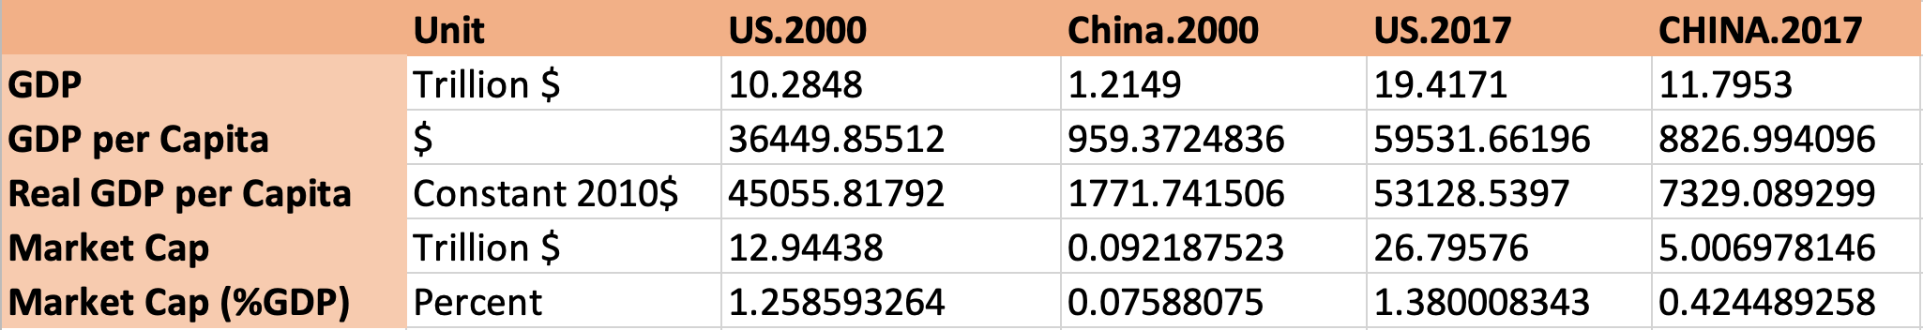

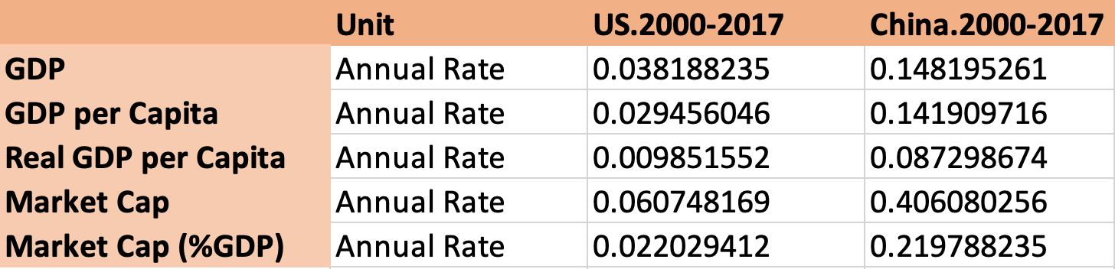

In the step we create a table to show the GDP level in the US dollar between the U.S and China at the end of 2000 and 2017. In the first table, we are comparing the GDP, GDP per capita, real GDP per Capita, market cap and market cap per % GDP between U.S and China. The data told us that the U.S. has 10 times in GDP compared to China. GDP per capita explains how individual citizen wealth in term of GDP in the country. GDP per capita in the U.S. was 36449 US dollars in 2000 compared to China GDP per capita only 959 US dollars. As we known that China is the largest world population. it is kind of understable that China had such of tiny GDP per capita. However, in 2017 we see that China GDP per capita has improved to 8826 per citizen. which explains that Chinese citizens are getting wealthier in term of GDP. Talking about the stock market, the U.S. is the largest investment holding market capitalization compared to the world. We understand that due to the free market country, political stable, and investing in infrastructures have convincing more investors to invest into the U.S market. In our second table, we computed the growth rate in the period of 2000 to 2017. The data tells us that, the U.S. GDP growth was 3.81% from 2000 to 2017 compared to China was 14.81%. This is an evidence of successfully internally government policy changed in China, once the government allowed to have free market in the country, and less restraints for foreign investors. In GDP growth per capita, we see that the U.S has 2.94% from 2000 to 2017 compared to China has 14.19%. Real GDP growth per capita which explains how well GDP do after adjusted the inflation per citizen. The U.S. has 0.985% of real GDP per capital where China has 8.72%. Market Capitalization growth in China is way bigger than the U.S. at the rate of 40%. This explains to us that, there are a new cash investment flew into the Chinese market.

**Step 2 : Stock Index**

**Step 2.1**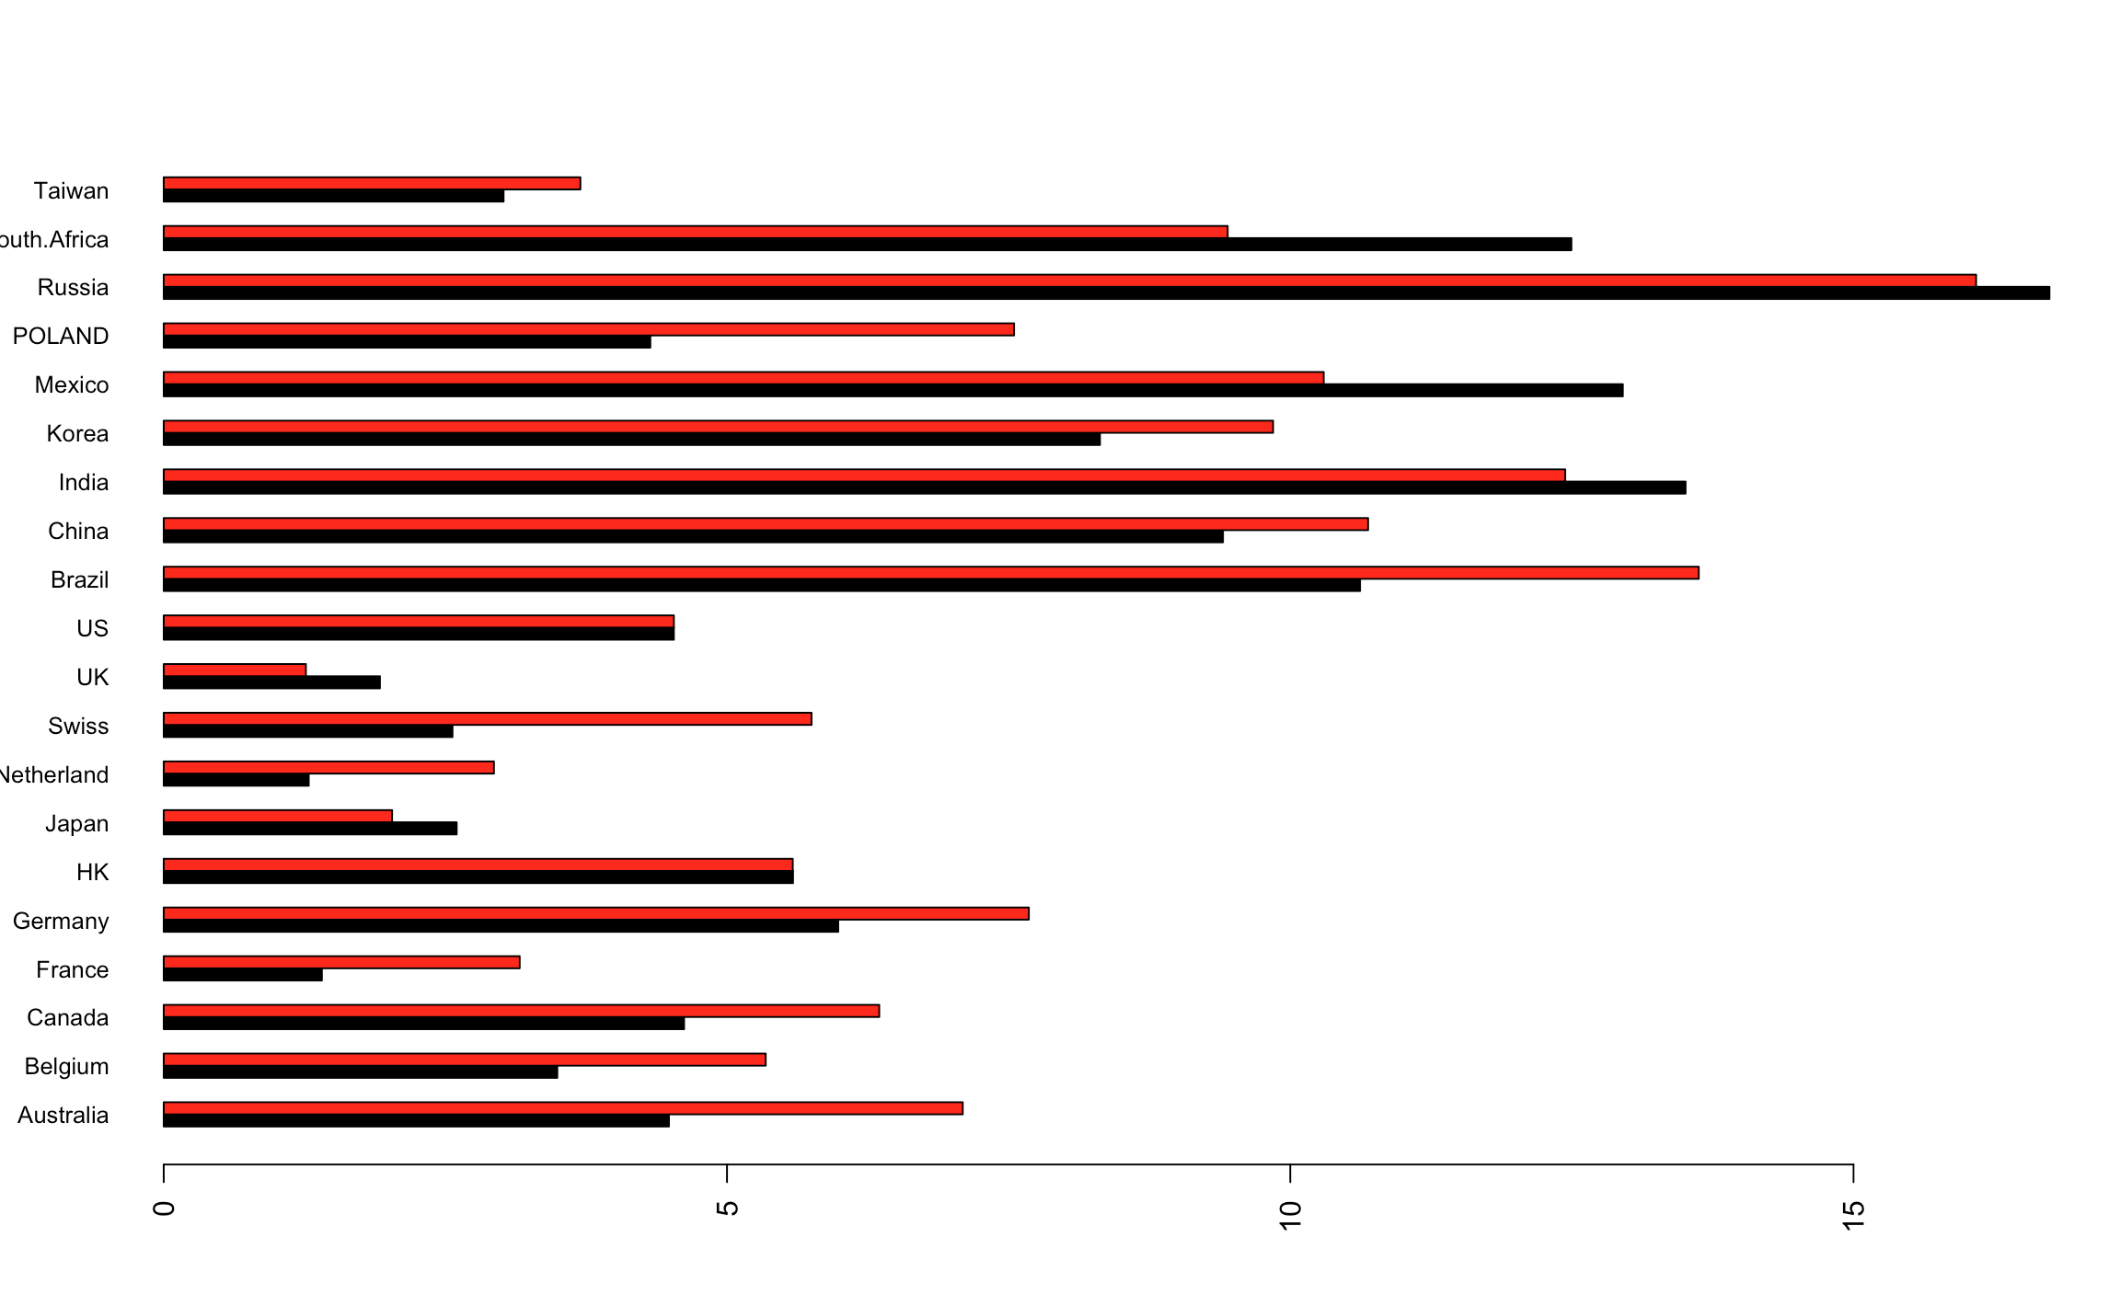

Figure 2.1 Vectical Bar Plot Average Returns

This graph above displays the average return of stock index and comparing between the U.S currency and the local currency. The x-axis shows percentage return of stock investment range from 0% up to 15% The y-axis displays the name of the counties. the red bars depict returns in local currencies while the black bars depict returns in dollars, adjusted for exchange rate movements. We used the baseline value at 6%. Most countries like Russia, Mexico, India and China have generated more than 6% average return in stock market. However, if we look clearly on the picture we see Russia, Mexico, and India has yield more return in US dollars. It’s clear that exchange rate fluctuations over this period had large effects on dollars, adjusted for exchange rate movements. However, if we look at the Chinese average stock return with local stock market return has yielded more return compared to dollar denominated in the country. This explains to us that the government might manipulated the local currency in order to keep amount of cash flow out of the country.

**Step 2.2**

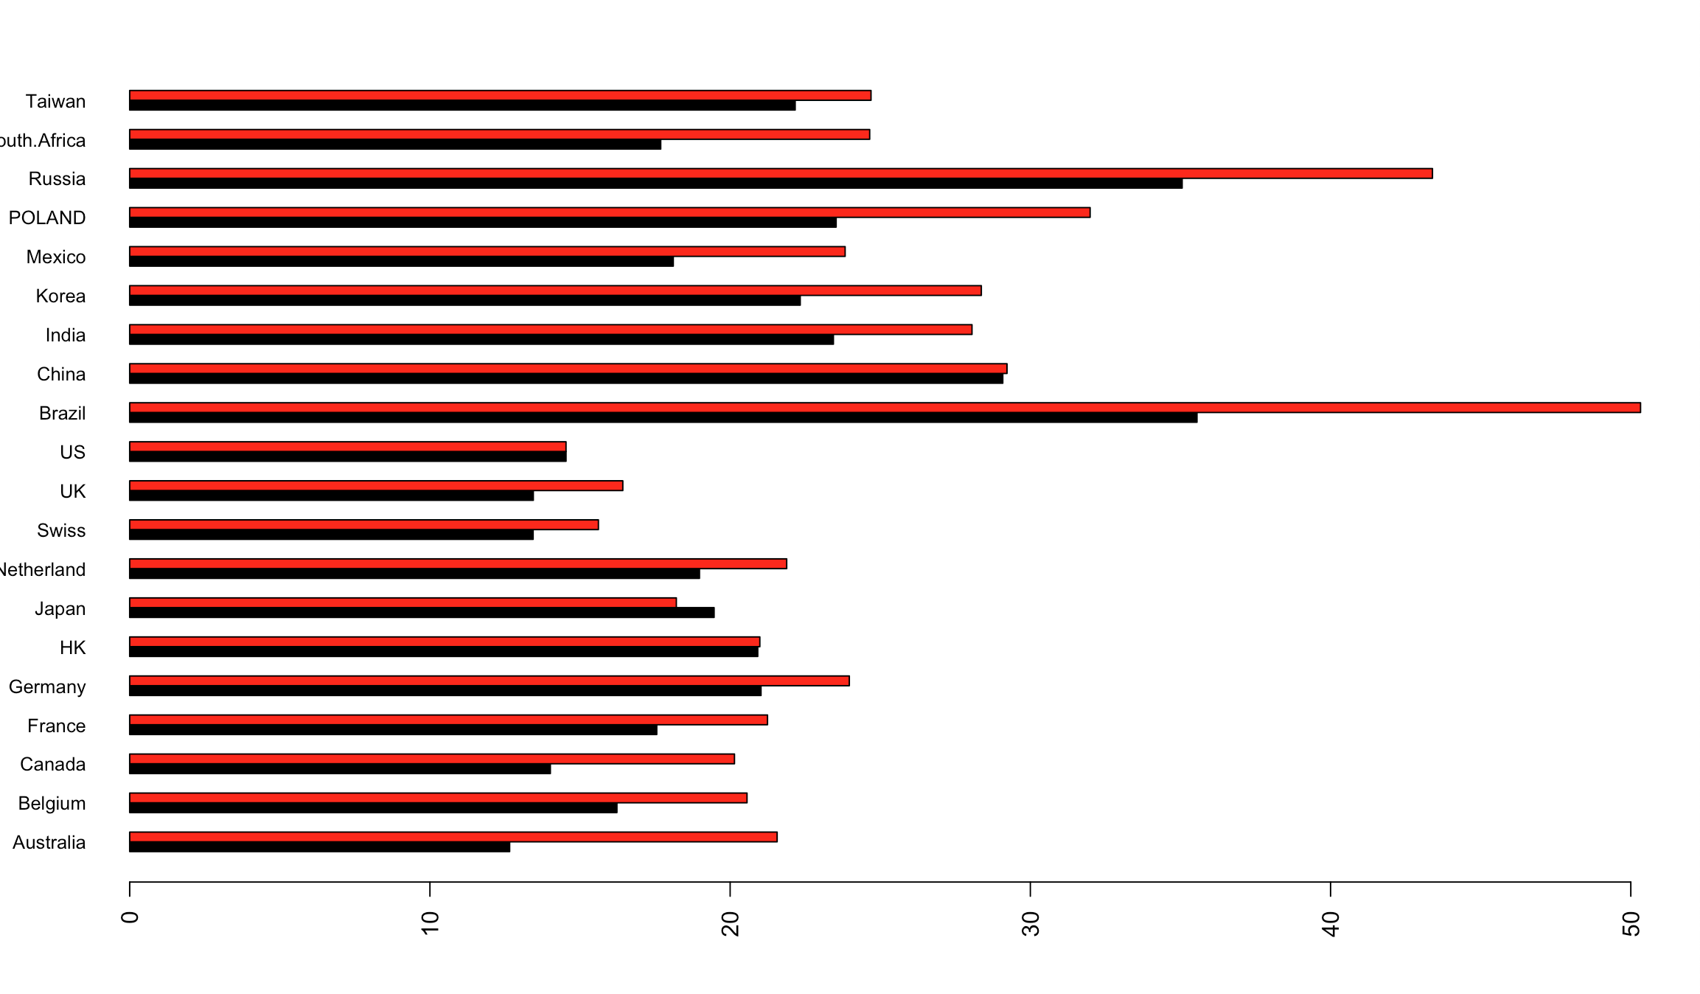

Figure 2.2 Vectical Bar Plot Standard Deviations

This graph above displays the standard deviation of the returns (annualized percentage) and comparing between the U.S currency and the local currency. The x-axis shows percentage standard deviation of return range from 0% up to 50%. The y-axis displays the name of the counties. the red bars depict returns in local currencies while the black bars depict returns in dollars, adjusted for exchange rate movements. We used the baseline value at 21%. Most countries like Russia, Brazil, India and China have more than 21% standard deviation of the return. It is clear that there are more risks to investing in these countries. we also understand that exchange rate fluctuations over this period had large effects on dollars, adjusted for exchange rate movements. However, if we look at the Chinese average stock return with local stock market return has yielded almost identical in term of standard deviation compared to dollar denominated in the country.

**Step 2.3**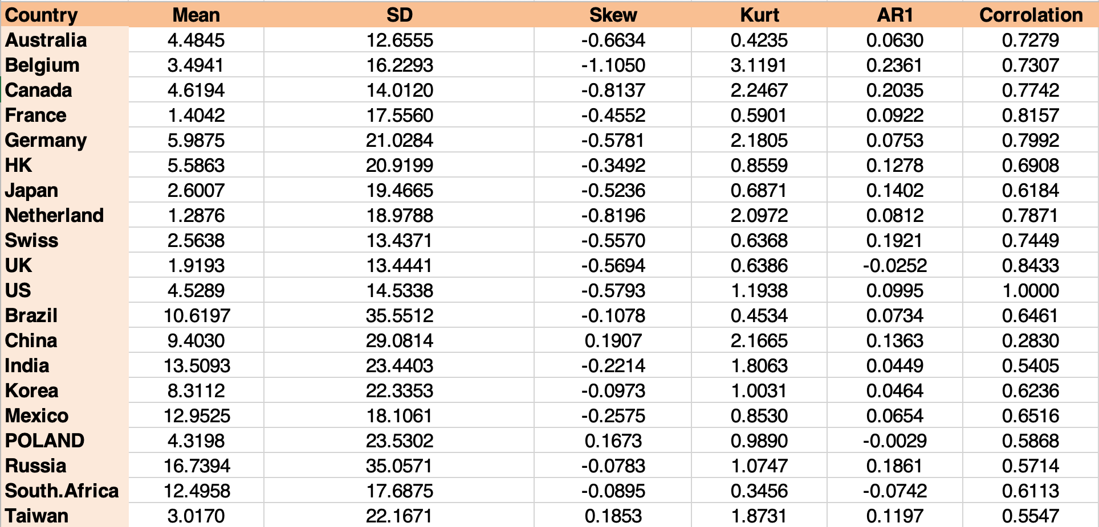

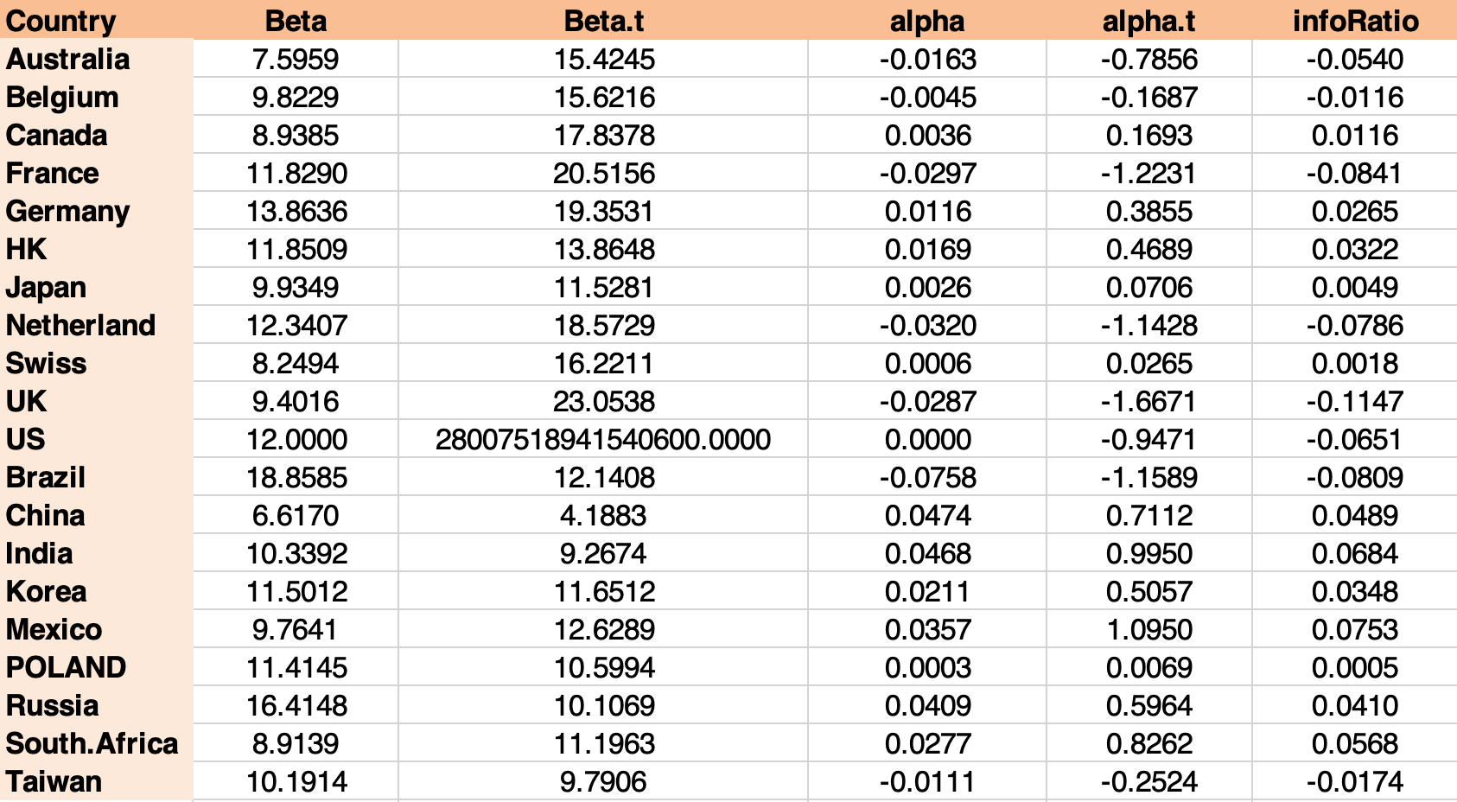

Figure 2.3 Local Returns Report Table

In this step, we created a table for the return (in local currency) mean (annualized percentage), standard deviation (annualized percentage), skewness, kurtosis and autoregressive lag (slope coefficient from AR(1) model). In addition, we created the table for correlation with the U.S, alpha (annualized percentage), beta, corresponding t-stats, and information ratio from the regression model. Above table explains that Russia has the highest percentage annualized return in local currency with the standard deviation of 35 percent. as we know the higher return we expect to get from investment will come along with the high risk. the country has the highest correlation to the annualized percentage return to the U.S is UK at level of 0.84.

**Step 2.4**

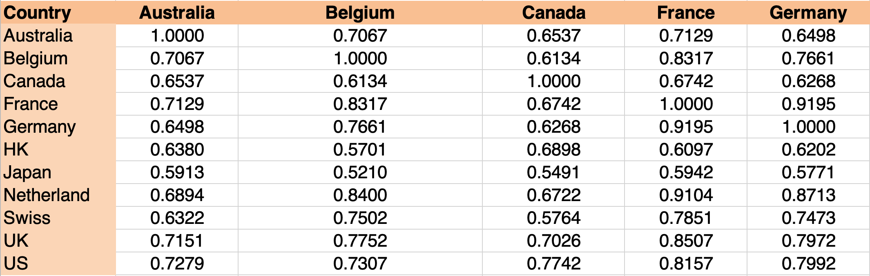

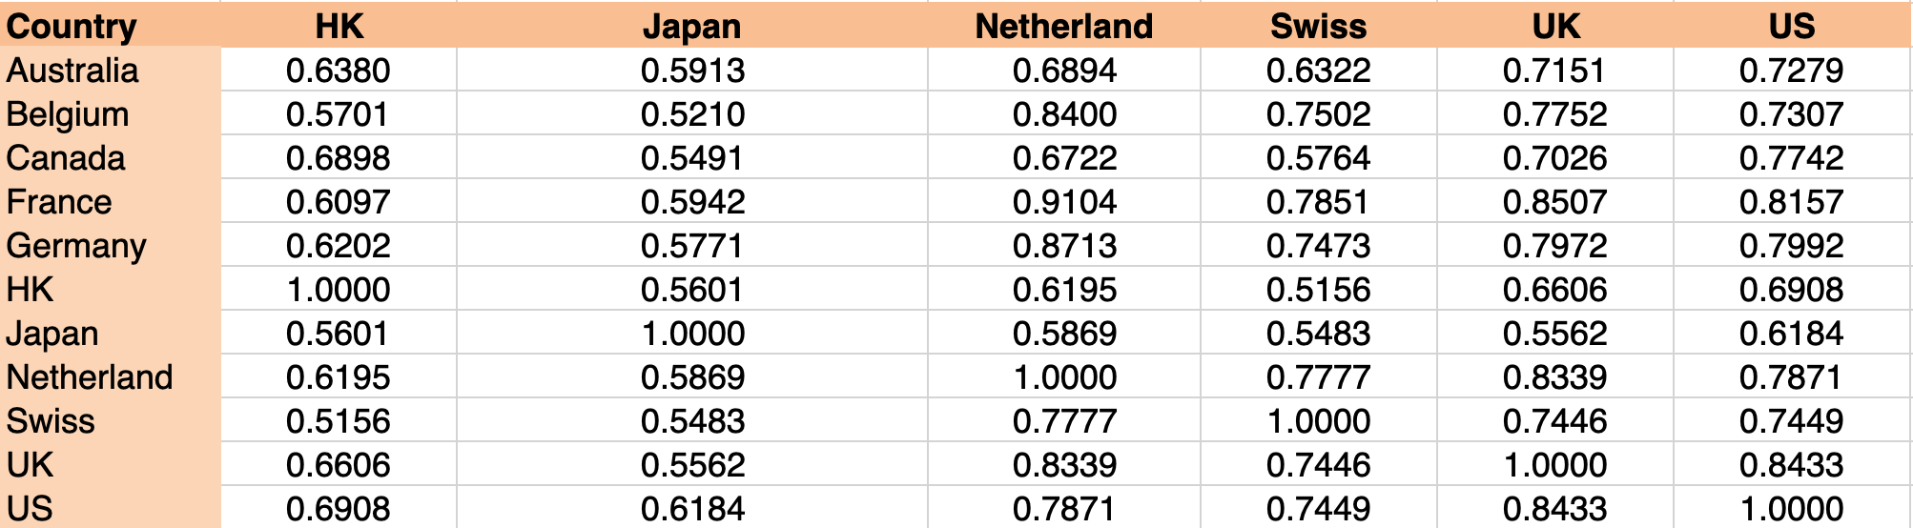

2.4.1 DM Correlation Table

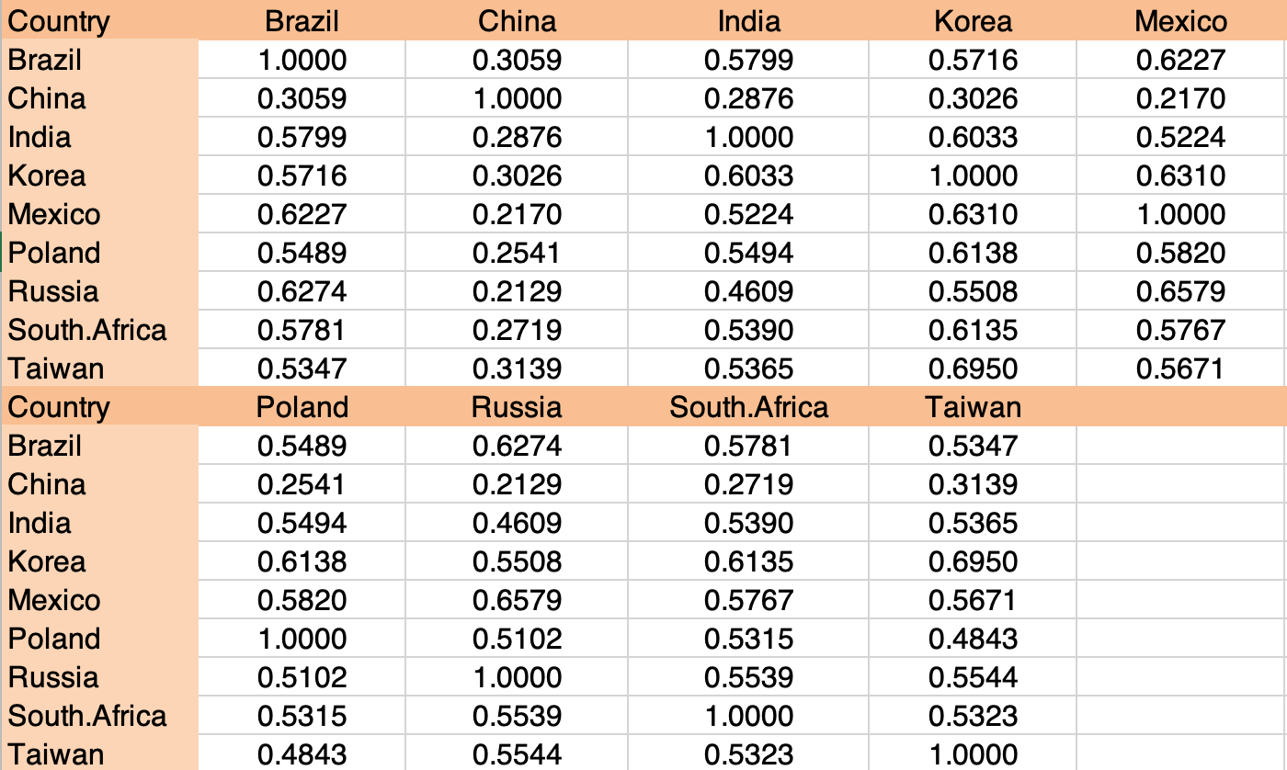

2.4.2 EM Correlation Table

In this step, we created a table for correlation for EM return within EM countries and DM return within DM countries. Above table explains that, in the developing market US has the strongest correlation to Australia at 0.72, Swiss also has a strong correlation to belgium. for the emerging market. We see that, Mexico has the strongest correlation to the brazil at 0.6227. China is a strong correlation to Taiwan.

**Step 2.5**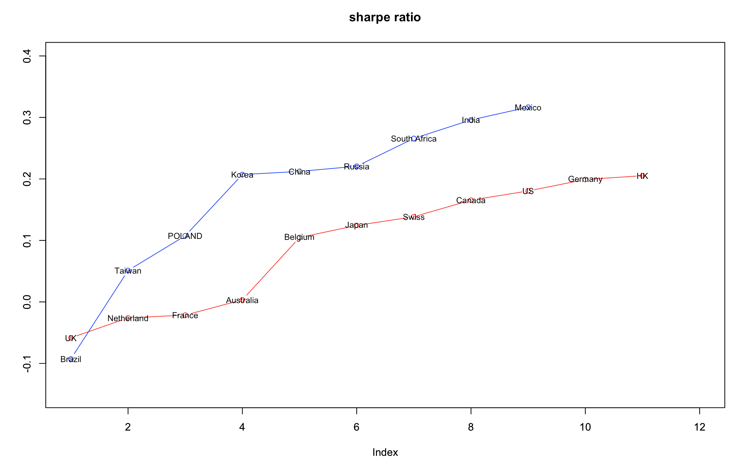

Figure 2.5.1 Sharpe Ratio Plot by Rank for full sample 2000-2017

The above graph shows the ranks of the Sharpe Ratios in the DM and EM countries. The x-axis tells the rank each country is at, and the y-axis tells the value of Sharpe Ratio. The blue line displays how the Sharpe Ratio ranks in DM countries. It is obvious that Brazil has the lowest Sharpe Ratio, which is -0.1 while Mexico has the highest Sharpe Ratio,which is 0.3. The red line displays the rank among the EM countries. UK has the lowest Sharpe Ratio, which is lower than 0, while HK has the highest one, around 0.2.

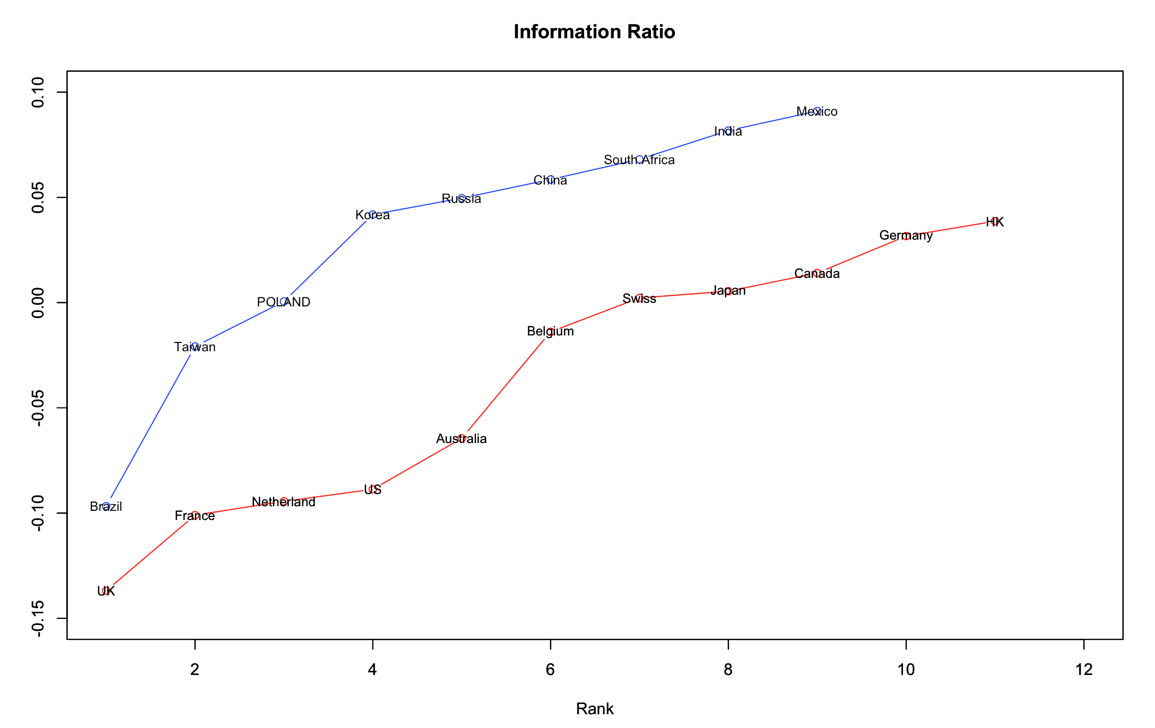

Figure 2.5.2 Information Ratio Plot by Rank for full sample 2000-2017

The above graph shows the ranks of the Information Ratios in the DM and EM countries. The x-axis tells the rank each country is at, and the y-axis tells the value of information Ratio. The blue line displays how the Information Ratio ranks in DM countries. It is obvious that Brazil has the lowest Information Ratio, which is -0.1 while Mexico has the highest Information Ratio,which is 0.3. The red line displays the rank among the EM countries. UK has the lowest Information Ratio, which is lower than 0, while HK has the highest one, around 0.2.

**Step 2.6-D13 : TAB Time varying risk premium: DM and EM Variance Risk Premium.**

2.6 Time Varying Risk Premium Table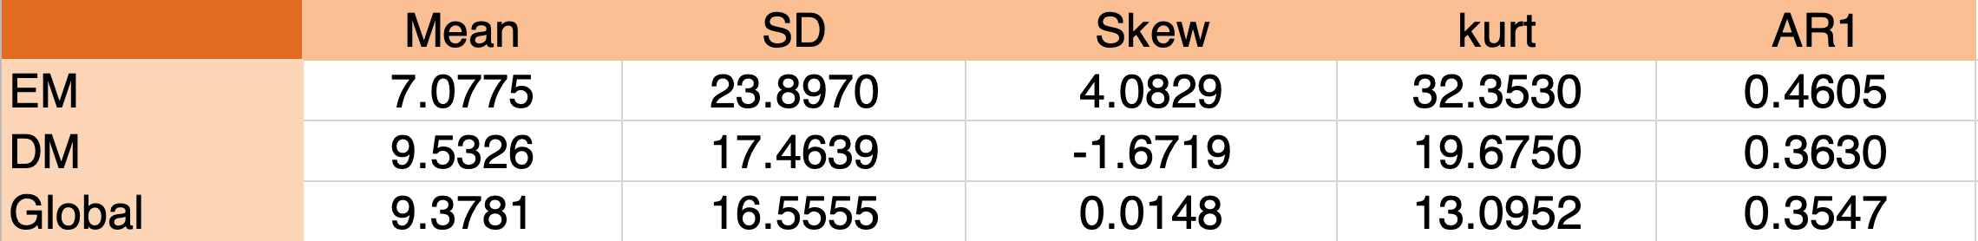

In this step, we created a table for time varying risk premium for Emerging Market and Develop Market. Variance risk premium can be interpreted as an important state variable measuring economic uncertainty. As a state variable, the CRP contains information about future investment opportunity set, and should predict future economic condition, such as stock market return and currency returns. alternatively, VRP can measure the agent’s risk aversion or regarded as the premium request in the variable swap rate market. In our table, we see the Developed market has bigger mean at 9.53 compare to the Emerging market. However, the standard deviation of for the Emerging market is higher than the Developed market at 23.89 where explain us that there is more variable uncertainty in the market compared to Developed market.

**Step 3: Exchange Rates**

**Step 3.1 TAB Basic summary statistics and correlation of exchange rate returns.**

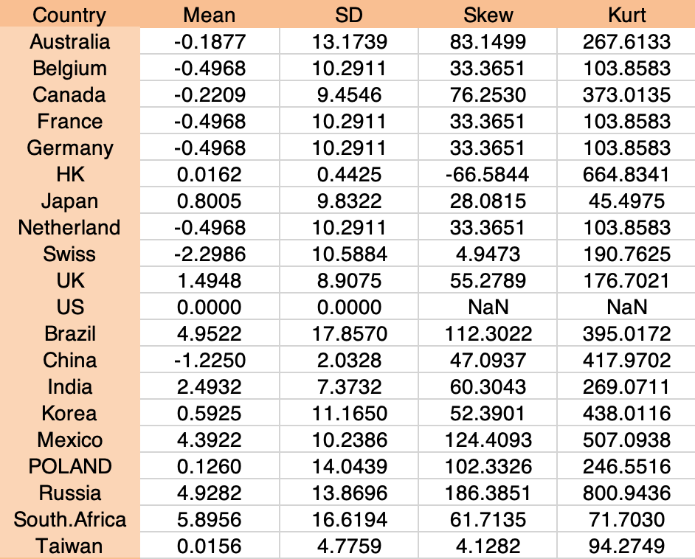

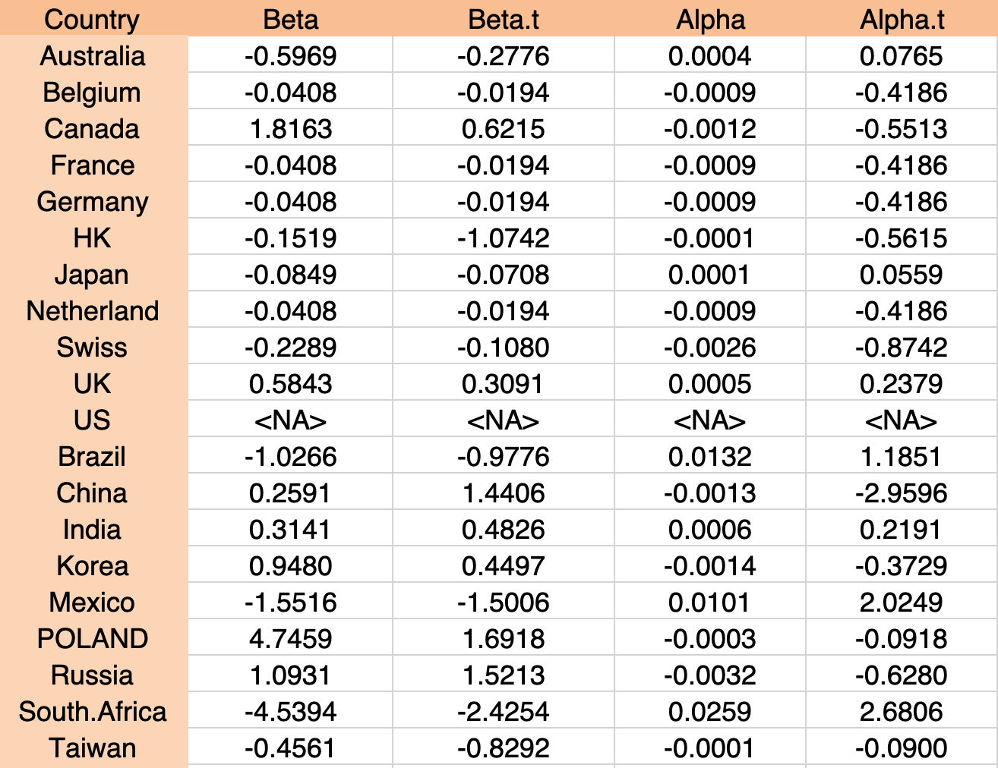

3.1 Basic Summary and Correlation of Exchange Rate Returns’ Table

In this step, we tried to generalized to understand and compare result for SD, beta coefficients, average excess return, and information ratios for both developed market and emerging markets using US dollars and local-currency return over the period 2010 to 2017. Both measures show that return in local currency are convincingly less risky than than dollar-denominated returns. the difference is greater when comparing beta.We see that Australian dollar depreciates relative to us dollar, resulting in australian dollar-denominated return of - 0.19. Standard deviation in this table represent the historical exchange rate risk measured by the deviation of monthly percentage changes in the exchange of major currencies against the U.S dollar over the period 2010 to 2017. the data show that currency risk is quite high. the annualized standard deviation of percentage changes in the exchange rate range 0.0044 to 0.1786. BRAZIL has a strongly positive correlation with the US Dollar, which mean we expect similar dollar returns from cash investments.

**Step 3.2 - D12 : TAB Basic summary statistics of risk free rates.**

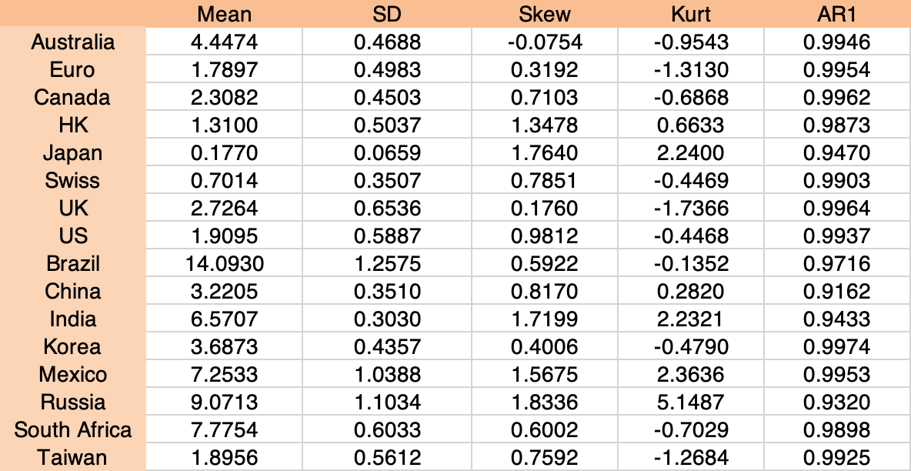

3.2 Basic Summary Statistics of Risk Free Rates Table

In this step, we tried to generalized to understand of risk free rates and compare result for SD, beta coefficients, average excess return, and information ratios for both developed market and emerging markets using US dollar and local-currency return over the period 2010 to 2017. We see that Australian dollar risk free rate at 4.44 relative to us dollar, resulting in australian dollar-denominated return. Standard deviation in this table represent the historical exchange rate risk measured by the deviation of monthly percentage changes in the exchange of major currencies risk free rate against the US dollar over the period 2010 to 2017. the data show that currency risk free rate is quite low. the annualized standard deviation of percentage changes in the exchange rate range 0.0659 to 1.25.

**Step 3.3 -D12 TAB summary statistics of risk free rates differentials (rfd)**

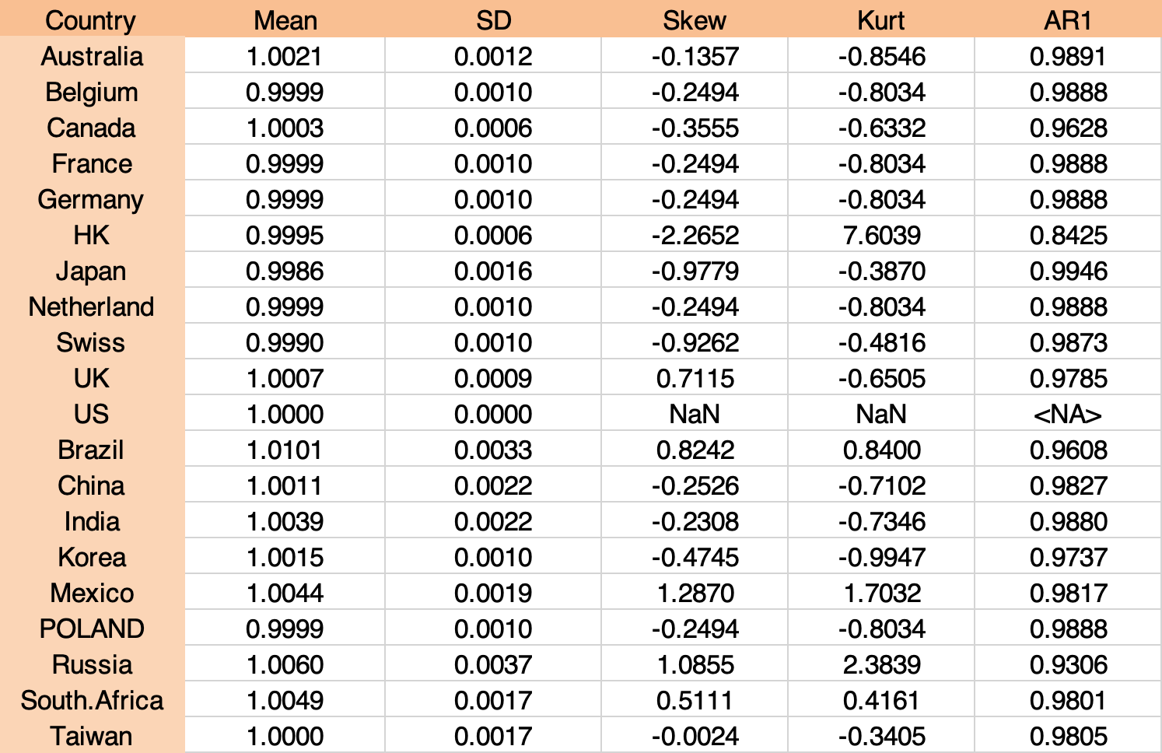

3.3 Summary Statistics of Risk Free Rates Differentials Table

In this step, we tried to generalized to understand the basis summary statistics of risk free rates of differential and compare result for SD, beta coefficients, average excess return, and information ratios for both developed market and emerging markets using US dollars and local-currency return over the period 2010 to 2017. We see that Australian dollar risk free rates differential is at 1.0021 relative to us dollar, resulting in australian dollar-denominated return. Standard deviation in this table represent the historical exchange rate risk measured by the deviation of monthly percentage changes in the exchange of major currencies risk free rates differential against the U.S dollar over the period 2010 to 2017. the data show that currency risk free rate is quite low. the annualized standard deviation of percentage changes in the exchange rate range 0.0006 to 0.0037.

**Step 4: Risk Aversion, Diversification and CML**

**Step 4.1 : TAB Do exercises ”What’s Your Risk Tolerance?” in Chapter 6 to pin down your risk aversion.**

*Note: Your risk level is the averaged risk aversion among different group members. *Note: 9-14 points (Conservative investor risk aversion is 10); 5-21 points (Conservative investor risk aversion is 5); 22-27 points (Conservative investor risk aversion is 1). For example, prof Xu scored 23/27 and her risk aversion is 1.

In this step, we builded 7 portfolios into our model to understand what is the risk tolerance we are going to maximizing in our utility function:

Portfolio 1: is dollar denominated DM stock index

Portfolio 2: dollar denominated EM stock index Portfolio

3: dollar denominated DM ”risk-free rate” excluding U.S riskfree rate portfolio

4: dollar denominated EM ”risk-free rate” Portfolio

5: U.S risk free rate. Portfolio

6: dollar denominated world stock index Portfolio

7: dollar denominated world ”risk-free rate” excluding U.S risk-free rate

where the dollar denominated stock market return and dollar denominated RF rate. We set our A level where is the coefficient of risk aversion at 6. we focus on conservative investment. our objective is to maximize diversification with limited expense and effort. we rely on the market efficiency to guarantee that a broad stock portfolio will yield the best possible shape ratio.

**Step 4.2 : TAB Construct these six risky assets and summarize the basic statistics and the correlation.**

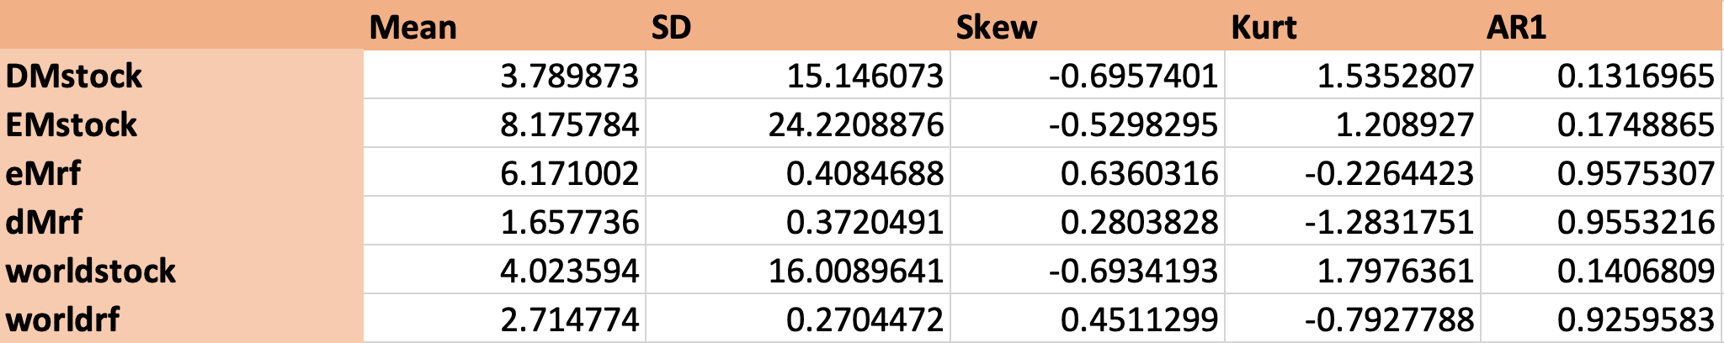

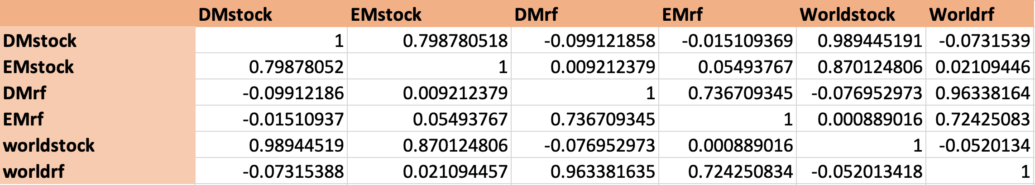

After set our risk A level of coefficient of risk aversion we want to see to evaluation our portfolio choice, we first ask whether this risk aversion is our exclusive investment vehicle by construct all the six risky assets. As we see in the table above. Emerging Market has yield better return compare other assets class which translated to 8.17% however, if we look at the standard deviation EM has 24.22 percentage. Those number told us that, there are higher risk to invest into emerging market than other asset class. Also, we want to look at the correlation for all asset class. we see that Develop market has the strongest correlation to the EM market. WorldStock also has strong correlation to DM market and EM market.

**Step 4.3 : RW If you are only interested in investing in DM countries, by maximizing the utility, what should be your weights on portfolio 1 and portfolio 3?**

In this step, if we are only interested in investing in DM countries and want to maximizing the utility. Our objective is to maximize diversification with limited expense and effort. we want to give the best possible shape ratio in our investment.We set our A level where is the coefficient of risk aversion at 6. with our coefficient of risk aversion we found our optimal weight index at for DM stock (Portfolio 1) is 13.44% and 87.66% into DM risk free rate (portfolio 3) in order to maximizing our return at the risk level we set. As an conservative investor we want to get more promising of return as we invested more weight in Risk free rate than into DM stock market.

**Step 4.4 : RW If you are only interested in investing in EM countries, by maximizing the utility, what should be your weights on portfolio 2 and portfolio 4?**

In this step, if we are only interested in investing in EM countries and want to maximizing the utility. Our objective is to maximize diversification with limited expense and effort. we want to give the best possible shape ratio in our investment.We set our A level where is the coefficient of risk aversion at 6. with our coefficient of risk aversion we found our optimal weight index at for EM stock (Portfolio 4) is 4.90% and 95.1% into EM risk free rate (portfolio 2 ) in order to maximizing our return at the risk level we set. As an conservative investor we want to get more promising of return as we invested more weight in risk free rate than into EM stock market.

**Step 4.5 : RW By maximizing the utility, what should be your weight on world stock (portfolio 6), world risk-free rate (portfolio 7) and U.S risk-free rate, respectively?**

In this step, if we are only interested in investing in world stock (Portfolio 6), world risk-free rate (Portfolio 7) and and U.S risk free rate. Our objective is to maximize diversification with limited expense and effort. we want to give the best possible shape ratio in our investment.We set our A level where is the coefficient of risk aversion at 6. Of course, we want to delocation our risk to adjust the risks. we clearly adding countries in order of return from low to high, quickly reduces portfolio risk despite the fact that standard deviation of all 3 portfolios, and yet improve the shape ratio of the overall portfolio with our coefficient of risk aversion we found our optimal weight index at for world stock (Portfolio 6) is 7.73% and 31.31% in world risk-free rate (Portfolio 7) and 60.1% into U.S risk free rate in order to maximizing our return at the risk level we set.

**Step 5 (optional): Performance Evaluation**

**Step 5.1 : RW Design your own trading strategy (buy and hold or timing the market) by taking a long or short position in these stock indexes, and or these exchange rates, and or these risk-free rates.**

In this step, we design our own trading strategy with the U.S investor perspective. we set our objective as a conservative investor. There would be no market timing. Also we want to diversify our portfolio to adjust the risks. By illustrated this method, we consider a hypothetical portfolio by investing in more into protection asset class where would be U.S risk free rate, world stock index, and money market securities. we set our neutral weights of 15% on world stock index, and 75% into U.S risk free rate, and 10 percent into money market securities.

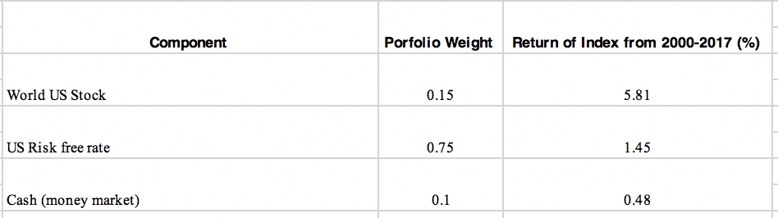

**Step 5.2 : RW Choose a relevant naive trading strategy as your benchmark portfolio.**

In this step, we want to see our excess return within the asset class compared to the benchmark return for that class multiplied by the portfolio weight for that class added to or subtracted from total performance.

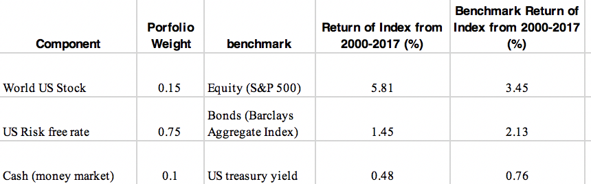

**Step 5.3 : RW Evaluate the performance of your portfolio vs this benchmark portfolio**

In this step, we want to evaluate our performance of our portfolio versus the benchmark portfolio we created.

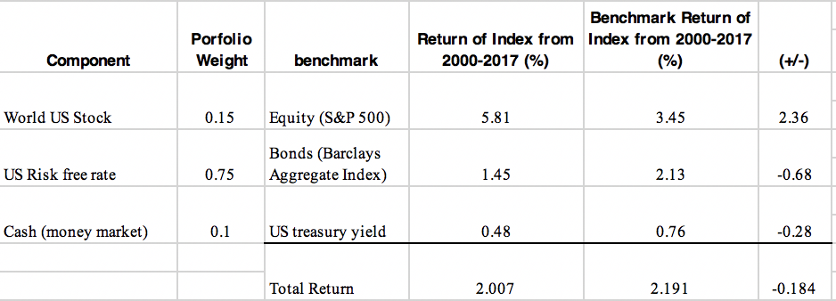

The table above shows the superior performance in all market weighted by the portfolio proportions invested in each market sums to 2.007% compared to the benchmark is 2.191%. which might due to disadvantage of our weight in each asset allocation and our attributable to sector selection within the each market. it showed that our U.S risk free rate component has a return of 1.45 and we are investing heavy weight in this index sector selection versus a return of 2.31% in barclays aggregate index.

|  |  |  |  |  |  |
| --- | --- | --- | --- | --- | --- |
|  |  |  |  |  |  |
|
|  |  |  |  |  |  |
|
|  |  |  |  |  |  |
|
|  |  |  |  |  |  |
|